*You are receiving this email as a member of the media.*

*If you wish to unsubscribe from future messages, please reply with UNSUBSCRIBE in the subject line.*

**NEWS RELEASE**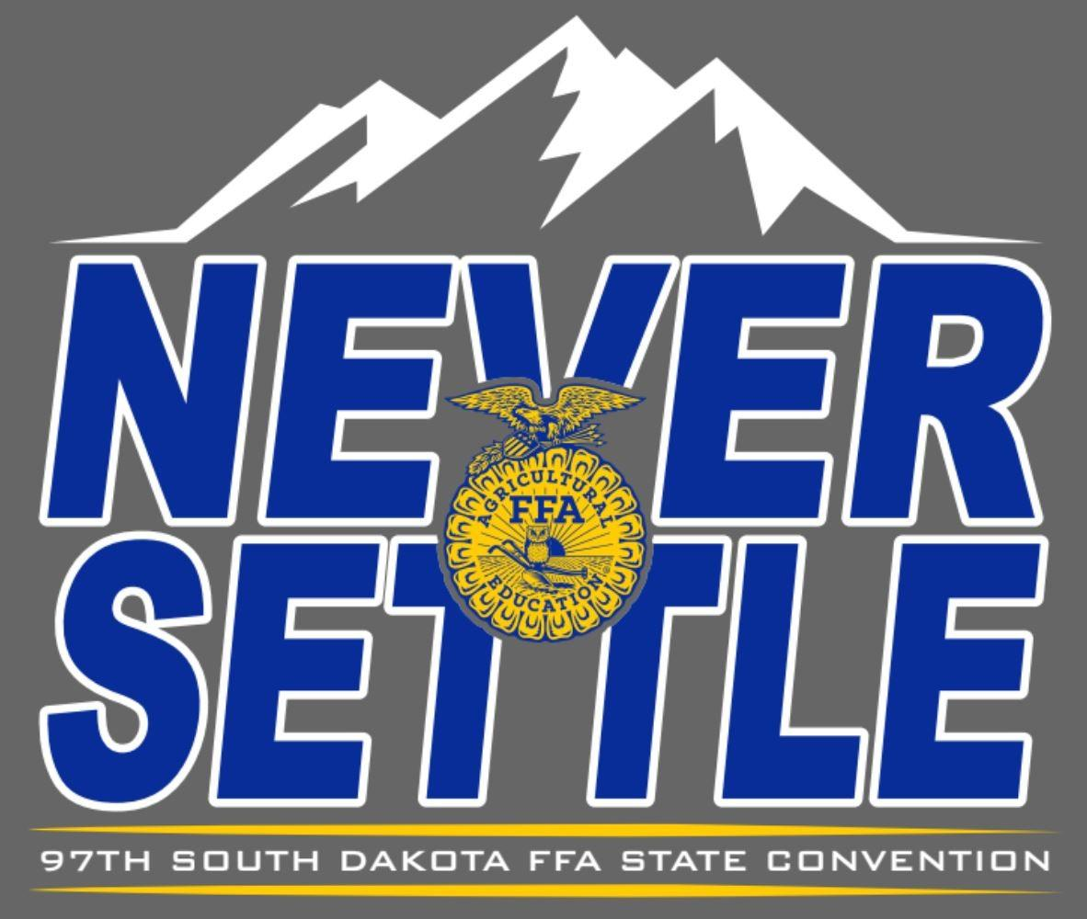

|  |
| --- |
| Website: [www.sdaged.org](http://www.sdaged.org) |
| Facebook: [www.facebook.com/South.Dakota.FFA](http://www.facebook.com/South.Dakota.FFA) |
| Instagram: @sdffaassociation |
|  |
| **For more information, contact:** |
| Caroline Hansen |
| South Dakota Leadership and Program Manager |
| Caroline.hansen@sdaged.org |

**South Dakota FFA Association**

**FOR IMMEDIATE RELEASE**

March 26, 2025

**FFA Members Receive State FFA Degree**

BROOKINGS, South Dakota – 324 South Dakota FFA members will be recognized for receiving their State FFA Degree at the 97th South Dakota State FFA Convention, Friday April 4th, 2024, at 4:00 pm. Join us in helping them celebrate! You can also watch the convention live at www.sdaged.org, Newscenter1.tv, and ConnectCenter1.tv and KAUN TV stations.

The State Degree is the highest honor the South Dakota FFA Association can bestow upon its members. In order to achieve the award, members must meet the following requirements; have received their Chapter FFA Degree, been an FFA member and agricultural education student for at least two years, earned at least $2,000, or worked 600 hours in their Supervised Agricultural Experience program, given a six-minute speech about agriculture or FFA, participated in eight different leadership activities, received a “C” average or better in high school and shown a record of outstanding leadership and community involvement.

As a special project of the SD FFA Foundation, South Dakota FFA members will receive the golden charm of the State Degree, a symbol of the member’s growth and development, and a framed certificate, thanks to the following sponsors: Todd & Barbara Powell; Barry & Jenny Jacobson; The Jacobson Group LLC; West Central FFA Alumni; Rechelle & Eric Dissing; Dan Streff Family; Sandy Osterday; CharLee Bachman; Kent Buchholz; Noelle & Andrew Swanson; Kevin & Amber Blagg; Steven Zemlicka; Myles & Mercedes Snedeker; Red River Farm Network; Dacotah Diamond Auctions and Equipment; Jeff & Beth Vanderwal; Peterson Livestock; First PREMIER Bank; Lance Howe; Kyle & Jordanne Arbach, Wyatt & Zana DeJong; Dani Herring; Stella Nagel; Olson Family; Dawnwind Dairy Goats; and Wendy Mortenson Agency.

The 324 FFA members who received their State FFA Degree are:

**Alcester-Hudson**

Ethan Bovill

Devin Hongslo

**Arlington**

Caden Phelps

Preston Singrey

**Belle Fourche**

Alexis Hogen

Taya Kirstine

Wyatt Lesmeister

Lydia Main

Bailey Moke

**Beresford**

Elana Andrews

Isaac Boden

Ethan Hauck

Talen Hazel

Kayla Jensen

Cole Johnson

Kylie Mockler

Capri Mullinix

Grace Norling

Andrew VanKekerix

Allie Westra

Bon Homme

Gram Gause

Addison Hovorka

Kolbe Jelsma

Jackson Kaul

Kenadee Kozak

Adley Scheuerman

Landon Schmidt

Anahwyn Soukup

Hunter Stark

**Bridgewater-Emery**

Braxton Burnham

Hayden Hofer

Austin Kjetland

Dawson Plagmann

Grace Stacken

Katrina Thon

Dylan Wollman

Jason Zeeb

**Brookings**

Ella Feucht

Mikalyn Kelly

Connor May

Kennedy Nemitz

Josie Nold

Riley Rasmussen

Mackenzie Steinhauer

Gabriel Stern

Jordyn Tibbs

Landin Tucker

**Buffalo Christian**

Josie Johnson

**Canton**

Cordelia Adams

Chance Riley

Jenna Vande Weerd

Corbin Winquist

**Centerville**

Isaac Marohl

**Chester**

Lexi Bauman

Madlyn Borecky

Karmen Bonnie Iverson

Isabella Ann Schmidt

**Clark**

Avery Lee

Lauren Luvaas

DeSmet

Gannon Michael Gilligan

Tanner J Tolzin

Dell Rapids

Megan Geraets

Saywer Geraets

**Doland**

Reganne Miles

Emma Schneider

Edmunds Central

Theodore Haerter

Kelsey Lehr

**Elkton**

Rylen Coe

Brooklyn Grooters

Ashton Neill

Caleb Seiler

Jack Skordahl

Jackson Smallfield

**Ethan**

Ashley Clauson

Hunter Dean

Cole Hinckley

William Kreth

Madisyn Raymond

**Faulkton**

Cord Brand

Charlie Deiter

Lincoln Dikoff

Reese Hadrick

Trey Machtemes

**Freeman**

Elizabeth Anderson

Claire Hofer

Justice Mehlhaf

Olivia Smith

Erica Swensen

**Garretson**

Lane Ellefson

Tyler Erickson

Jakob Gnadt

Colin Shellum

Martin Welch

**Gregory County**

Nick Kenzy

Avery Zeisler

**Groton**

Kellen Antonsen

Ashley Johnson

Payton Mitchell

**Harrisburg**

Isabelle Madelynn Carlson

Khloe Johnsen

Andrew Johnson

Mason Kieffer

Elizabeth Kockelman

Briley Rilling

Cooper Rilling

Leia Rombough

Isabella Smithback

Conner Weber

**Hitchcock-Tulare**

Blaze Binger

Cooper Cole

Lainee Humphrey

Mikael Nielson

Katelyn Schroeder

Nick Tollefson

**Hot Springs**

Alexandra Burgess

Jayla Evans

Lyzzie Rapp

**Hoven**

Ethan Johnson

Abilene McGuire

Taylyn Rausch

Erica Sautner

Lane Stuwe

**Howard**

Ellie Becker

Melanie Marie Calmus

Lucas Feldhaus

Trent Gunnar Feldhaus

Calvin Halverson

Carson Hinker

Mason Daniel Jacobson

Tate Miller

Austin Mark Severson

Harris Terwilliger

**Huron**

Erianna DeVries

Hannah Schoenfelder

Kenna Dickson

**Kimball**

Graden Holan

Shayda Ness

Madilynn Von Eye

**Lemmon**

Gage Anderson

Blake Drayton

Blair Ham

Sidney Maher

Emma O’Donnell

Nathan Penfield

Cash Schiley

Samuel Weishaar

Arlus Yalowizer

**Lennox Sundstrom**

Megan Luvaas

Skyler Plucker

Faith Poppens

Tyler Strasser

Madison Central

James M Bame

Ava Caroline Brandenburger

Carter Downs

Cole Downs

Brayden Gust

Trevor Harms

Cambree Hunsley

Kade Klein

Lyndsey Litz

Ryan Morse

**McCook Central**

Preston Bradley

Abbie Chase

Lane Deutsch

Landon Flogstad

Joseph Grady

Blake Klitzke

Madison Lauck

Dylan McGregor

Lauren Roling

Ava Sieverding

Colton Stiefvater

Karlie Stiefvater

**Milbank**

Veronica Fonder

**Miller**

Eli Batin

Marshall Conkey

Emma Fritzsche

James Fritzsche

Kellan Hurd

James Lammers

**Mitchell**

Lainee Forst

Cailee Kirkpatrick

Ashlyn Roudabush

Delaney Zoss

**Montrose**

Cloey Deters

Makarie Wiebersick

**Northwestern**

Patrick Olson

Adiana Ratigan

Jessica Spurr

Dallas Stoltenberg

**Oldham-Ramona-**

**Rutland**

Garet Wicks

**Parker**

Halle Berens

Michael Even

Jerry Friman

Nevaeh Podhradsky

Allison Skinner

**Parkston**

Drew Braley

Breckin Culbert

Taylor Fink

Elliott Leischner

Emily Walz

**Philip**

Alex Baker

Jensen Fitch

Fayth Martin

Race O’Connor

Wade Piroutek

Mattisen Reckling

Morgan Sammons

Ashley Schriever

Lukas VanderMay

**Platte Geddes**

Coy Bultsma

Rehme Dibbet

Justin Groon

Emily Hickey

Emmit Holzbauer

Josie Muilenburg

Sydney Neuman

Kalli Summerville

Riley Timmerman

**Rapid City Stevens**

Jadyn Bennett

Henry Hovde

Alexa Roland

Patty Timmons

Daphne White

Tucker Wuertzer

**Redfield**

Creighton Bowar

Collin Dean

Brooklyn Rische

Logan Siebrecth

**Sanborn Central/ Woonsocket**

Emilie Lindgren

**Scotland**

Trinity Bietz

Emily Dvorak

**Sioux Falls CTE**

Brody Stenger

Amanda Wolf

**Sioux Valley**

Kylie Christensen

Matthew Field

Cayce Hoeke

Luke Lembcke

Mathew Olson

Elise Owen

Trevor Shultz

Seth VanderWal

**Sisseton**

Hannah Hannasch

Bradley Hansen

Sidney Johnson

Kate Meyer

Mason Shultz

Taylor Snaza

**Sturgis**

Bennett Gordon

**Sully Buttes**

Evia Buhler

Ely Heuertz

Taydon LaRosh

Teghan Westphal

**Sunshine Bible Academy**

Jimmy Burma

Savannah Hall

Kennedy Keck

**Tea Area**

Colton Duffy

Remington Jacobson

Megan Ritnour

Parker Wilson

**Tri-Valley**

Espn Althoff

Corral Benson

Zoe Dissing

McKenzie Dow

Brea Janes

McKenzie Mack

Ireland McAreavey

Emery Pearson

Reagan Pearson

Carson Sanders

Bracken Sharpe

Kylie Slining

Corie Wicks

**Viborg-Hurley**

LaMiya Baker

Parker Christensen

Rachael Feiock

Justin VanHull

**Wall**

Lonnie Elshere

Faith Frink

Natalie Mickelson

Lucy Moon

Laramie Nutter

**Webster**

Dylan Carlson

Blaise McGregor

Jaidryn Rice

Norah Zubke

**Wessington Springs**

Landen Christensen

Lucas Christensen

Ranick Fjerstad

Braden Flowers

Karter Mebius

Sam Poncelow

Ridge Roduner

Bailey Yost

**West Central**

Allison Brost

Mya Joan Marie Davidson

Reece Gerlach

Cain Grocott

Hannah Haase

Samuel Handberg

Aiden Healy

Kasey Kalb

Seth Lind

Natalie Morgan

Cooper Mulder

Cody Opitz

**Willow Lake**

Cayson Trav Bratland

Elliot Hayden Bratland

Samantha Jo Brenden

Kaylyn Marie Hofer

Josh Mark Kannegieter

Shay Marie Michalski

Nora Jean Terhark

Tehya Catherine Vig

Ginny Warkenthien

**Wilmot**

Mya Heinje

Rhyanna Rudebusch

**Winner**

Austin Blare

Andrew Henderson

Kyla Mammen

Hunter Shippy

**Wolsey-Wessington**

Rachel Boomsma

Brylee Furhman

Modesty Heath

-###-